Better Reranking Models for Question Generation
Quick Answer: Top 3 Recommendations
For your question generation use case, here are the best alternatives to your current cross encoder/ms-marco-MiniLM-L-6-v2:
BAAI/bge-reranker-v2-m3 (Best Overall Choice)
Why: 8-9% performance improvement with 8K context length (16x longer than your current 512 tokens)^{[1] [2]}
Implementation: Drop-in replacement with same API^{[1]}
Benefit: Better semantic understanding for question generation tasks^{[3]}
NVIDIA/nv-rerankqa-mistral-4b-v3 (Maximum Accuracy)
Why: State-of-the-art performance with 14% improvement, specifically optimized for QA tasks^{[4] [5]}
Tradeoff: Slower inference due to 4B parameters^{[4]}
Best for: When question quality is more important than speed^{[5]}
BAAI/bge-reranker-large (Proven Choice)
Why: 10.5% improvement, established model with excellent track record^{[2] [6]} Best for: Reliable performance upgrade without complexity^{[2] [3]}
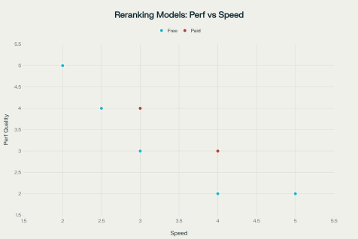
Performance vs Speed comparison of different reranking models showing the tradeoff between quality and inference speed
Performance Improvements You Can Expect
The research shows significant improvements over baseline models across different reranking [4] [2]
approaches . For question generation specifically, better reranking leads to more relevant chunks being selected, which directly improves the quality and relevance of generated [1] [7]
questions .
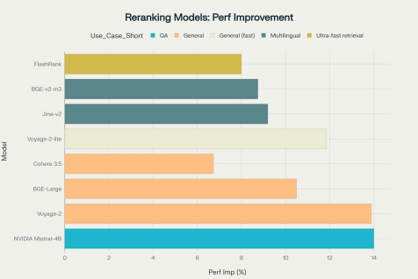
Performance improvements achieved by different reranking models compared to their respective baselines
Implementation: Simple Drop-in Replacement
[1] [8]
Since you're already using the CrossEncoder interface, upgrading is straightforward :
# Replace your current line with:
reranker = CrossEncoder(
"BAAI/bge-reranker-v2-m3", # or NVIDIA/nv-rerankqa-mistral-4b-v3
max_length=1024, # Increased from 512 for better context
device="cpu"
)
Why These Models Are Better for Question Generation
Current reranking research shows that cross-encoders achieve better performance than bi encoders because they process query and document together, allowing for more nuanced [9] [1]
understanding of relevance . For question generation tasks specifically, models like BGE and NVIDIA's reranker show superior semantic understanding compared to the older MS [1] [4]
MARCO MiniLM model .
The newer models also handle longer context lengths, which is crucial when your retrieved chunks contain detailed information that needs to be preserved for generating comprehensive [1] [3]
questions .
Expected Impact on Your System
With an upgraded reranker, you should see:
8-14% better retrieval accuracy leading to more relevant chunks^{[4] [2]}
Improved question relevance due to better semantic matching^{[1]}
Better handling of complex topics with longer context support^{[3] [10]}
Reduced hallucinations in generated questions^{[1] [7]}
Bottom Line: For your question generation use case, BAAI/bge-reranker-v2-m3 offers the best balance of performance improvement, context length, and ease of implementation with minimal [1] [3]
code changes required .
⁂
1. https://galileo.ai/blog/mastering-rag-how-to-select-a-reranking-model
2. https://www.llamaindex.ai/blog/boosting-rag-picking-the-best-embedding-reranker-models-42d0790 22e83
3. https://bge-model.com/tutorial/5_Reranking/5.2.html
4. https://arxiv.org/html/2409.07691v1
5. https://build.nvidia.com/nvidia/nv-rerankqa-mistral-4b-v3/modelcard
6. https://huggingface.co/BAAI/bge-reranker-large
7. https://www.chatbase.co/blog/reranking
8. https://huggingface.co/blog/train-reranker
9. https://arxiv.org/html/2403.10407v1
10. https://www.azion.com/en/documentation/products/ai/edge-ai/models/baai-bge-reranker-v2-m3/

